Güralp Data Centre
  - Operator manual

Contents
Acquisition software components diagram 2
Overview 3
Software components 3
Operating system 3
Requirements 3
Security 3
Configuration 4
IRIS ringserver 4
Ringserver miniSEED files storage location configuration 4
Ringserver miniSEED files storage auto-clean configuration 4
slinktool 4
slink2dali 5
Güralp Data Centre controller service 9
Güralp Data Centre monitor service 9
Güralp responder service 10
Güralp Discovery application 10
Operation 11
IRIS ringserver 11
slinktool 12
slink2dali 12
Güralp Data Centre controller service 12
Güralp Data Centre monitor service 13
Güralp responder service 13
Güralp Discovery application 14
State of Health 14
Configuration 19
Support 21
Version 21

Acquisition software components diagram
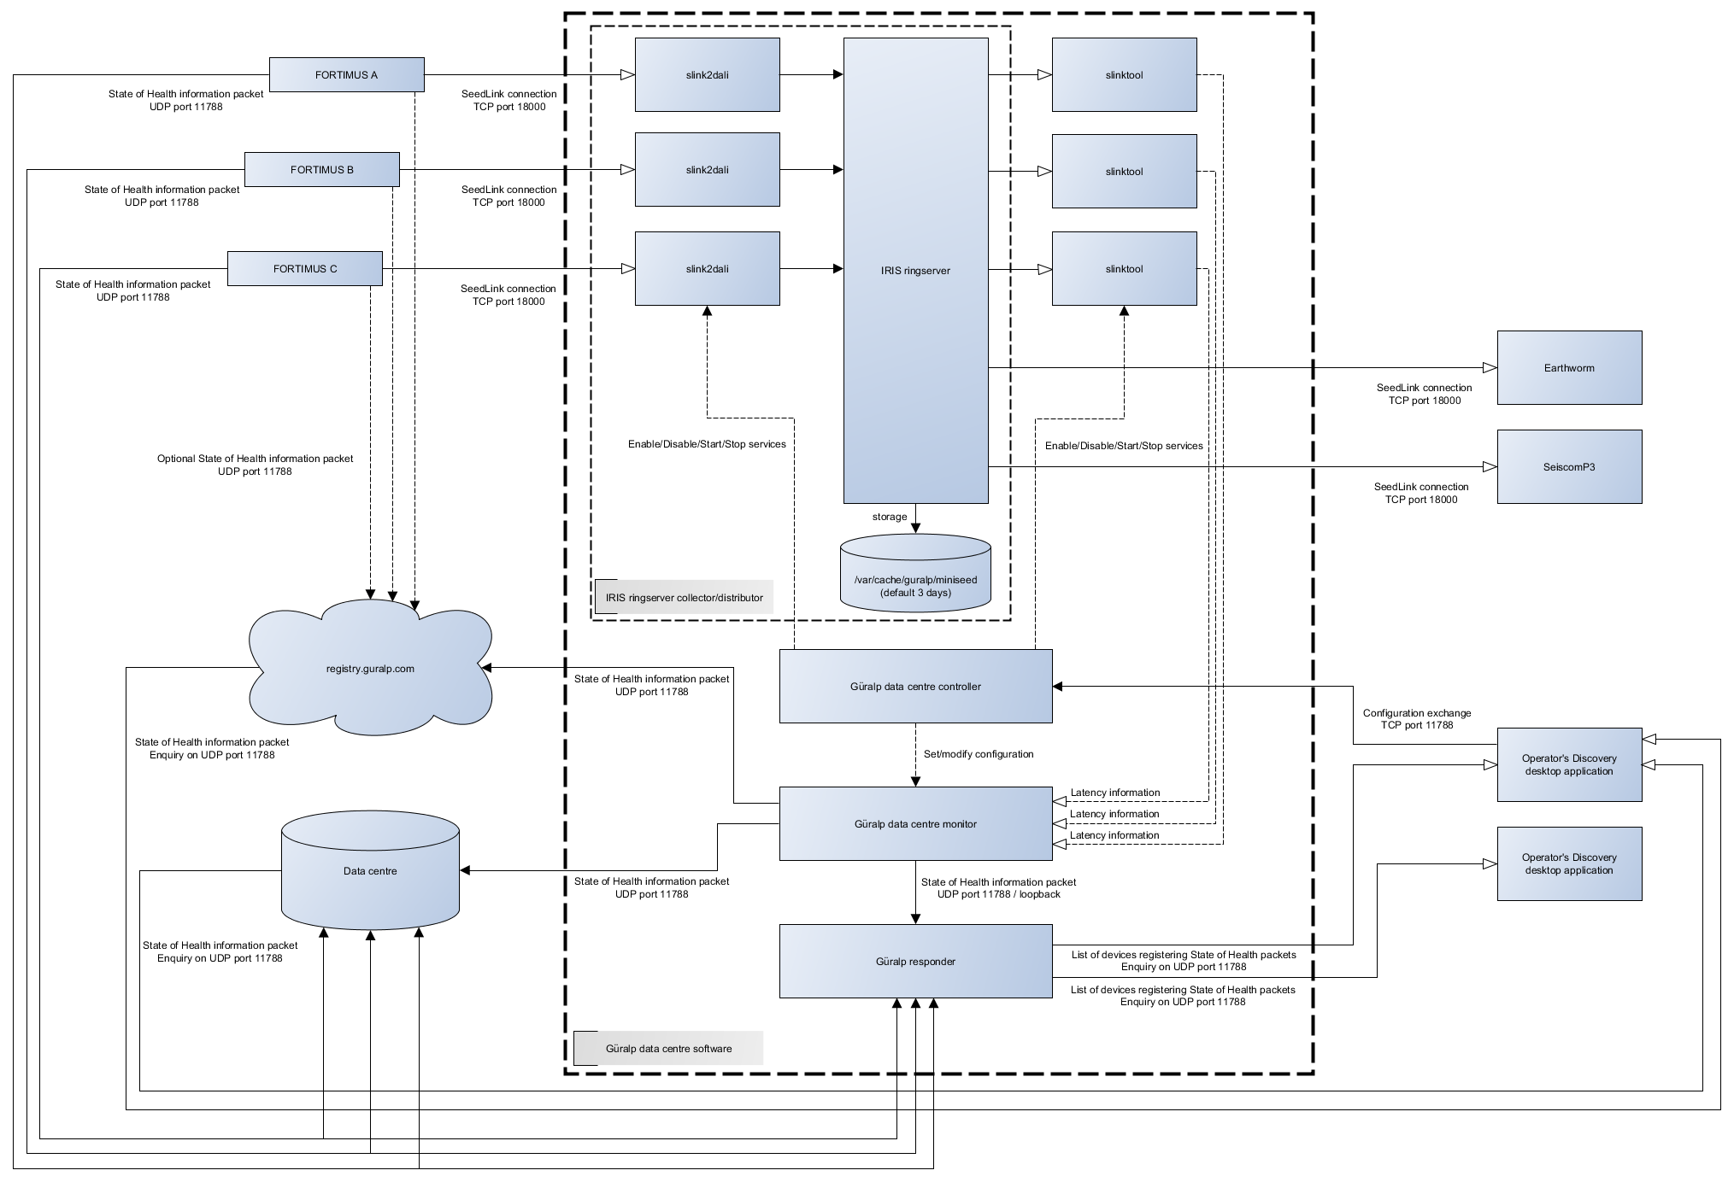

Overview
Güralp Systems Data Centre software package (Acquisition software package) consists of several applications providing system state of health monitoring, data collection and distribution, and remote configuration capabilities. This document describes how to use and configure selected components of the software package.

Software components
List of all applications present in the software components diagram:
- IRIS ringserver
- slinktool
- slink2dali
- Güralp Data Centre controller service
- Güralp Data Centre monitor service
- Güralp responder service
- Güralp Discovery application
Optional components:
- Earthworm client
- SeiscomP3 client

Operating system

Requirements
Güralp Systems Data Centre software package has been tested on the following x86_64 platforms:
- Red Hat Enterprise Linux 8 (or equivalent, e.g. Rocky Linux 8 or AlmaLinux 8)
- Amazon Linux 2
Support for other platforms might be considered upon request (minimum system dependency requirements are: systemd v239, Qt v5.12.5, polkit v0.115).

Security
Güralp Systems Data Centre software requires access to the network in order to operate correctly. Please make sure that the system security settings allow the network traffic to and from the machine on ports specified in the table below. It also might be needed to configure SELinux features in relation to the mentioned requirements.
Port | Protocol | Description
11788 | UDP | Used for sending and requesting state of health information by system components and Discovery desktop application.
11788 | TCP | Configuration exchange protocol used by Discovery desktop application to configure data streaming connections.
16000 | TCP | DataLink data transmission protocol connection to IRIS ringserver.
18000 | TCP | SeedLink data transmission protocol connection to IRIS ringserver for both incoming and outgoing data streams.

Configuration

IRIS ringserver
IRIS ringserver does not require any specific configuration unless change in either default storage location (/var/cache/guralp/miniseed/) or time for which the data is kept on the hard drive is required. Application runs as an operating system service and listens for SeedLink connections on TCP port 18000. If required listening port is different to 18000 please contact support@guralp.com for instructions.

Ringserver miniSEED files storage location configuration
IRIS ringserver storage location is configured by the home directory of ringserver user and if required can be changed by system administrator by editing the user properties. Newly selected directory should have sufficient permission and ownership. The steps below show how to modify the home directory of the ringserver user in Red Hat linux environment (please note that commands may require elevated permissions).
- Copy tmpfiles.d guralp-miniseed.conf file to /etc system location
cp /usr/lib/tmpfiles.d/guralp-miniseed.conf /etc/tmpfiles.d/guralp-miniseed.conf
- Edit the copied configuration file and append a new line specifying the new storage location:
d /run/guralp/etc 0755 root root
F /run/guralp/etc/iris-ringserver.conf 0640 root ringserver - MSeedWrite %%n_%%s_%%l_%%c_%%Y_%%j.mseed
d /var/cache/guralp/miniseed 0775 root ringserver 3d
d /mnt/new/storage/directory 0775 root ringserver 3d
- Save the changes made to the file
- Modify the ringserver user home directory
usermod -d /mnt/new/storage/directory ringserver
- Reboot the system to apply the changes
Please note that only the following top directories can be used: /home /media /mnt /opt /srv /var

Ringserver miniSEED files storage auto-clean configuration
IRIS ringserver storage is controlled by system tmpfiles clean timer and can be configured by editing guralp-miniseed.conf file. In order to change the configuration of time that historical data is kept in the system please follow the steps below.
- Copy tmpfiles.d guralp-miniseed.conf file to /etc system location
cp /usr/lib/tmpfiles.d/guralp-miniseed.conf /etc/tmpfiles.d/guralp-miniseed.conf
- Edit the copied configuration file and change the age of storage location to the required value.
d /run/guralp/etc 0755 root root
F /run/guralp/etc/iris-ringserver.conf 0640 root ringserver - MSeedWrite %%n_%%s_%%l_%%c_%%Y_%%j.mseed
d /var/cache/guralp/miniseed 0775 root ringserver 3d
where 3d is the age of temporary files (read more: https://www.freedesktop.org/software/systemd/man/tmpfiles.d.html).
- Save and reboot the system

slinktool
Slinktool process runs as a service with parameters provided through the service name in a form of a ‘@’ separated list of values. Under normal operation there is no requirement to manually configure (enable/disable or start/stop) the service, this task is performed by the Data Centre controller on remote request from the Discovery desktop application.
Manual service configuration can be performed but it is not recommended. In order to do that, please log in to the Data Centre computer and use systemctl command to enable/disable and/or start/stop the slinktool service. Slinktool service is run with a set of parameters:
slinktool@NC@STATC@LOCHN@CONNECTION@PORT.service
where:
- NC, is SEED network code,
- STATC, is SEED station code,
- LOCHN, is SEED location and channel codes
- CONNECTION, is the connection IP address or hostname, for latency monitoring in the Data Centre this is set to 127.0.0.1 (localhost)
- PORT, is the connection port
Wildcard character for SEED location and channel name can be used and is represented by ‘_’ character. Also, a list of location and channel names can be provided to a given service and should be separated with ‘-‘ character.
Example:
slinktool@DG@0585A@_____@127.0.0.1@18000.service, will connect to station 0585A of DG network, subscribing to any channel (wildcard selector of 5x ‘_’ character).
slinktool@DG@0585A@0NHHZ-0NHHN-0NHHE@127.0.0.1@18000.service, will connect to station 0585A of DG network, subscribing to 0N.HHZ, 0N.HHN and 0N.HHE channels.

slink2dali
Slink2dali process runs as a service with parameters provided through the service name in a form of a ‘@’ separated list of values. Under normal operation there is no requirement to manually configure (enable/disable or start/stop) the service, this task is performed by the Data Centre controller on remote request from the Discovery desktop application.
In order to configure the required connection (slink2dali and slinktool services) use the Discovery desktop application.
- Open Discovery desktop application and change the view to “Registry” mode
- Right click on the Data Centre instance
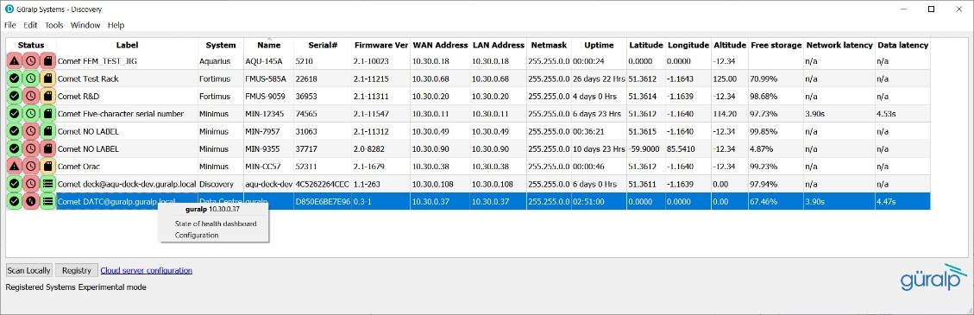
- Select Configuration option
- In the configuration widget, if not preloaded with configuration, click on “Restore” button to retrieve the Data Centre configuration.
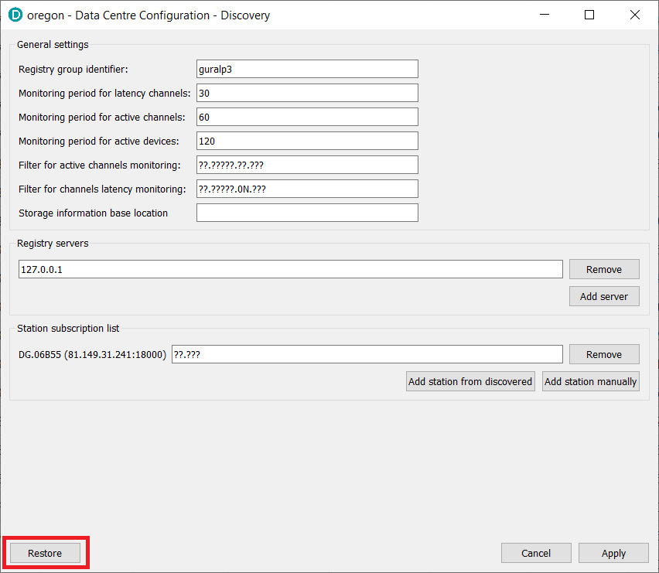
- Widget populates the list of currently configured connections and provides control button to remove the connection if no longer required. Connection subscription channel list can contain multiple SEED channel names (LOCATION_CODE.CHANNEL_CODE) defined as a space (‘ ‘) separated list.
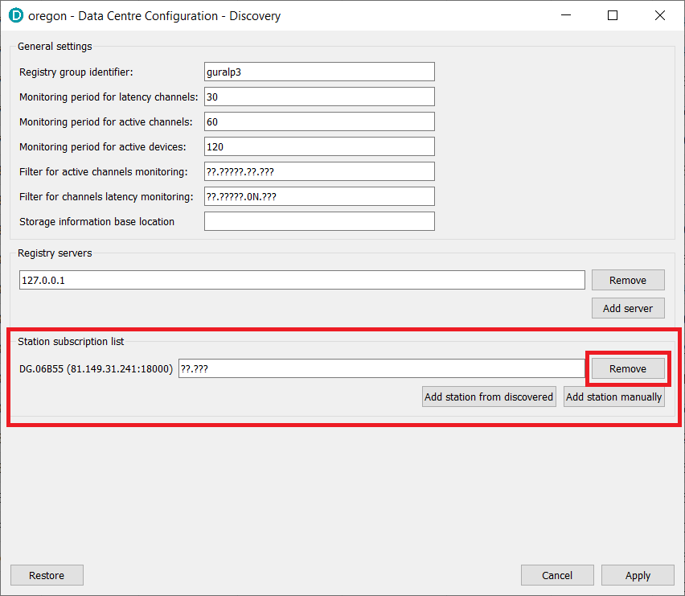

- Connections can be quickly added from the list of stations populated in the Discovery desktop application main window through “Add station from discovered” button, or manually by clicking on “Add station manually”.
  - Add station from discovered.
When actioned, new widget with a list of discovered stations is displayed and tick-boxes are available for selecting to which stations the Data Centre should connect to. Once list contains required stations, press “Add selected” button to confirm.
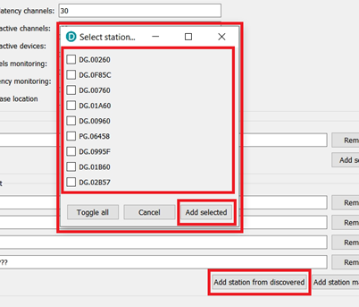
  - Add station manually
To add device that is not supporting Güralp Discovery mechanism, please press on “Add station manually” button which populates a simple widget asking for details required to create the connection from the Data Centre to the device.
Required fields:
    - SEED Network code
    - SEED Station code
    - Connection IP address
To confirm, click on “Add station” button.
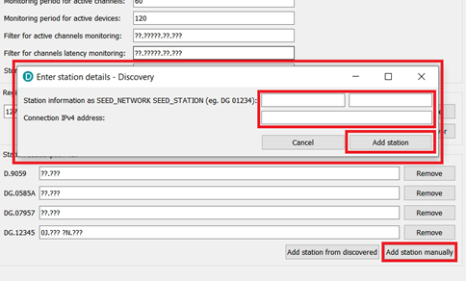

- When all connections are added to the list, click “Apply” button to send the updated configuration to the Data Centre. Date Centre controller service will enable and start all required slinktool and slink2dali services. If station was removed from the list, the controller service will stop and disable the services used to connect to the removed device.
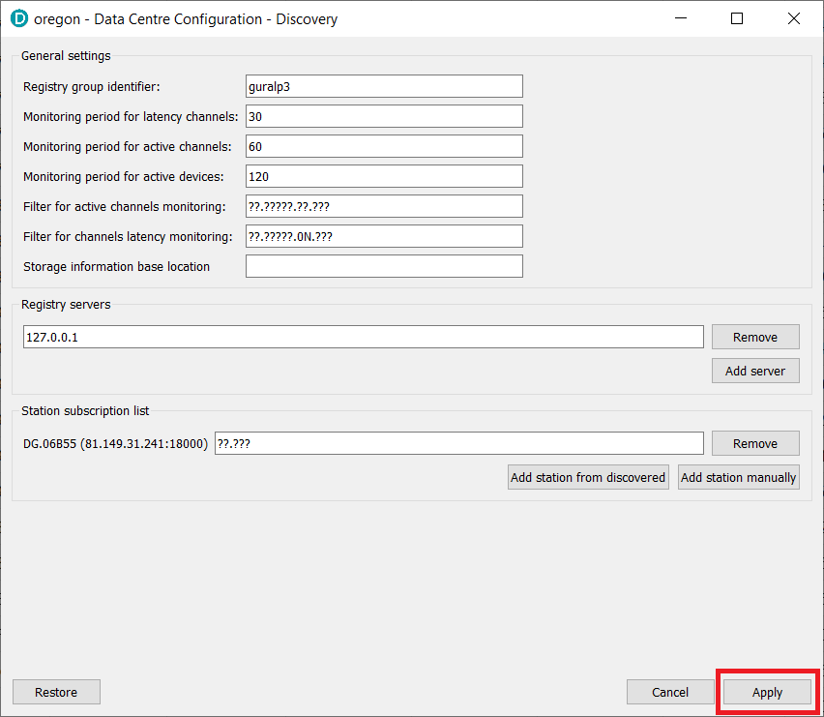
Note: Other configuration fields are explained in the Discovery application configuration section of this document.
Manual service configuration can be performed but it is not recommended. In order to manually configure a connection, please log in to the Data Centre computer and use systemctl command to enable/disable and/or start/stop the slink2dali service. Slink2dali service is run with a set of parameters:
slink2dali@NC@STATC@LOCHN@CONNECTION@PORT@STATEFILESAVEINTERVAL.service
where:
- NC, is SEED network code,
- STATC, is SEED station code,
- LOCHN, is SEED location and channel codes
- CONNECTION, is the connection IP address or hostname
- PORT, is the connection port
- STATEFILESAVEINTERVAL, defines interval for state file save (can be blank)
Wildcard character for SEED location and channel name can be used and is represented by ‘_’ character. Also, a list of location and channel names can be provided to a given service and should be separated with ‘-‘ character.
Example:
slink2dali@DG@0585A@_____@10.30.0.123@18000.service, will connect to station 0585A of DG network using IP address 10.30.0.123 and port 18000 subscribing to any channel (wildcard selector of 5x ‘_’ character).
slink2dali@DG@0585A@0NHHZ-0NHHN-0NHHE@10.30.0.123@18000.service, will connect to station 0585A of DG network using IP address 10.30.0.123 and port 18000 subscribing to 0N.HHZ, 0N.HHN and 0N.HHE channels.

Güralp Data Centre controller service
Güralp Data Centre controller does not require any specific configuration. Application runs as a service and does not need particular maintenance.

Güralp Data Centre monitor service
Güralp Data Centre Monitor service should be configured remotely by accessing Configuration widget in the Discovery application. The configuration widget is available under right-click menu of a Data Centre row.
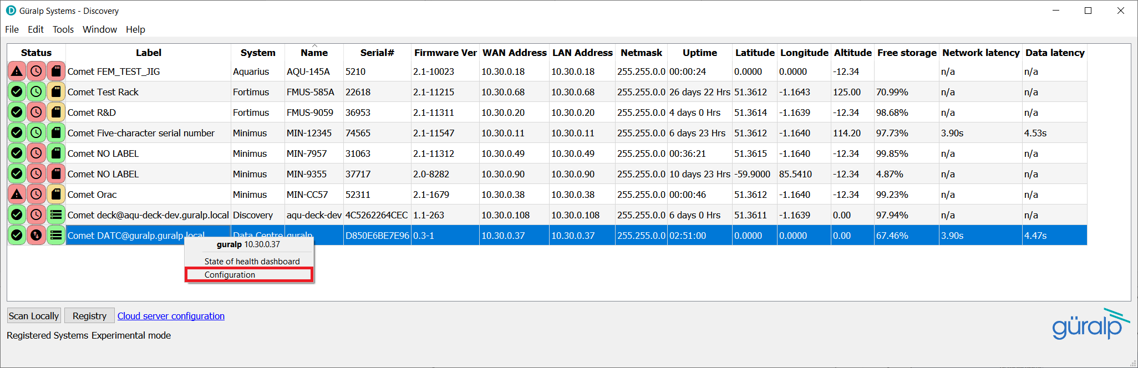
Manual configuration can be performed but is not recommended. Configuration is stored in a configuration file located in /var/cache/guralp/guralp-monitor.ini and contains a set of key-value entries:
Key | Description | Type
registry_addresses | Comma separated IP addresses of Güralp responder servers to which the state of health packet should be send to | Comma separated list of strings
registry_group_id | Güralp responder server group identifier string used. Please use “guralp3” as a default value | String
filter_monitored_channels | SEED globing style filter for channels activity monitoring | String
filter_monitored_latency_channels | SEED globing style filter for channels latency monitoring | String
monitoring_period_latency | Period of time in seconds that should be used to find the highest data latency | Integer
monitoring_period_active_channels | Period of time in seconds that should be used to detect number of active channels | Integer
monitoring_period_active_devices | Period of time in seconds that should be used to detect number of active devices | Integer
storage_monitor_dir | Directory that should be used for storage monitoring, if this entry is not present, iris ringserver working directory is used. | String
Example guralp-monitor.ini file content:
[Version_1]
filter_monitored_channels="^.{1,2}\\..{1,5}\\..N\\..{1,3}"
filter_monitored_latency_channels="^.{1,2}\\..{1,5}\\..N\\..{1,3}"
monitoring_period_active_channels=120
monitoring_period_active_devices=300
monitoring_period_latency=30
registry_addresses=127.0.0.1,
registry_group_id=guralp3
storage_monitor_dir=/var/cache/guralp/miniseed

Güralp responder service
Güralp responder service provides a configuration option for specifying a wildcard group identifier that grants access to all of the registered devices. Wildcard group identifier can be used in the Discovery desktop application to list all of the stations that are connected to the Data Centre even if they are registering with a different, non-matching, group identifiers.
Wildcard group identifier can be set by creating a configuration file under tmpfiles.d directory. The configuration file generates the content of /run/guralp/etc/wildcard_groupid.txt file that is read by the responder service on startup and the content is used as the wildcard. To configure a custom wildcard string please follow the steps below.
- Copy tmpfiles.d configuration file to system location.
cp /usr/lib/tmpfiles.d/guralp-responder.conf /etc/tmpfiles.d/guralp-responder.conf
- Edit the configuration file /etc/tmpfiles.d/guralp-responder.conf to generate the selected wildcard string.
Example content of /etc/tmpfiles.d/guralp-responder.conf
d /run/guralp/etc 0755 root root
F /run/guralp/etc/wildcard_groupid.txt 0640 root guralpmonitor - customWildcard
Where, customWildcard is the new wildcard string.
- Save the modified file.
- Restart the operating system.

Güralp Discovery application
Güralp Discovery desktop application when used for monitoring the state of health of the Data Centre has to be configured to use the Data Centre IP address as a Cloud registry server. Discovery supports multiple cloud registry endpoints and these are configured under File/Settings menu action, also accessible by clicking on the “Cloud server configuration” label of the application main window.
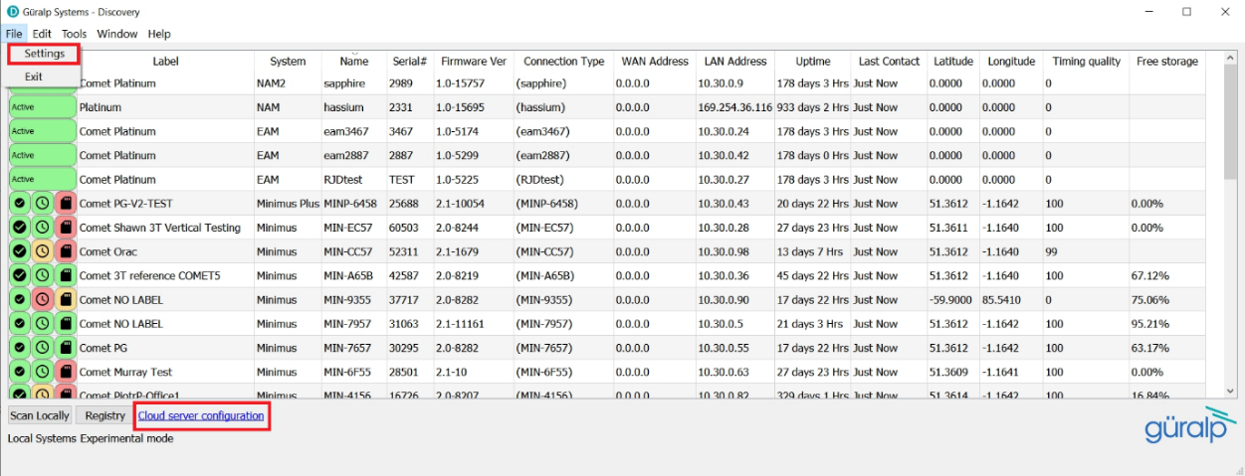
To add a cloud registry endpoint, please click on an “Add” button in the “Cloud registry” section and provide endpoint hostname or IP address. Please note that hostnames will get automatically translated to IP address and stored as IPv4 address.
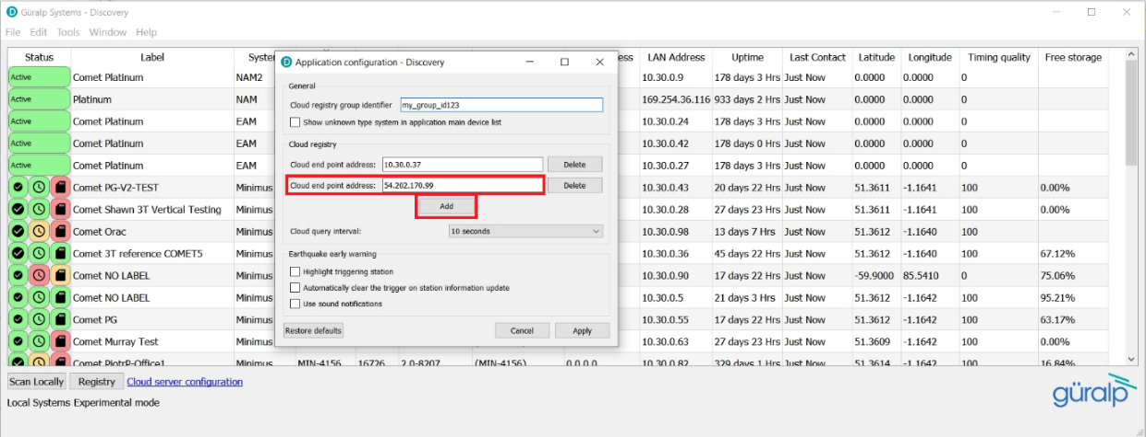
When all of the Data Centre instances are added to the list, click on the “Apply” button to confirm the changes.
It is important to set the “Cloud registry group identifier” field to reflect the configuration of the Data Centre Monitor and the Güralp seismic stations (e.g. Minimus or Fortimus). Misconfiguring this setting will cause the list of active devices to be blank in the “Registry” mode of the Discovery application.
To reduce the amount of network traffic, the frequency of state of health information packet requests from the Cloud server can be configured by changing the “Cloud query interval” setting.

Operation

IRIS ringserver
IRIS ringserver service status is displayed in State of Health dashboard of the Data Centre instance and should be regularly monitored to assure correct operation of the software. The State of Health dashboard is available under right-click menu of the Data Centre row in the Discovery desktop application.
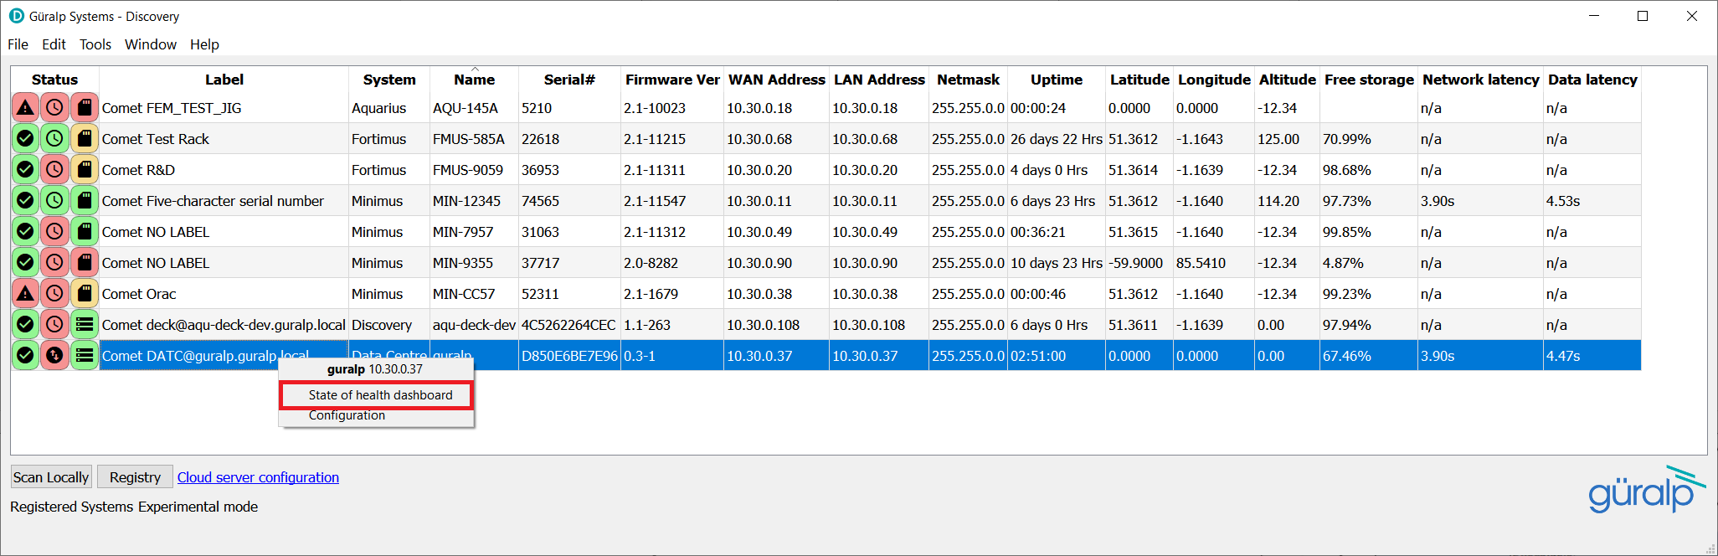
Bottom left part of the dashboard provides information about the state of services required for correct data centre operation. If for any reason service displayed as “iris-ringserver.service” is not listed as “active”, please log in to the Data Centre computer and investigate using systemctl tools. If problem persists, please contact Güralp support.
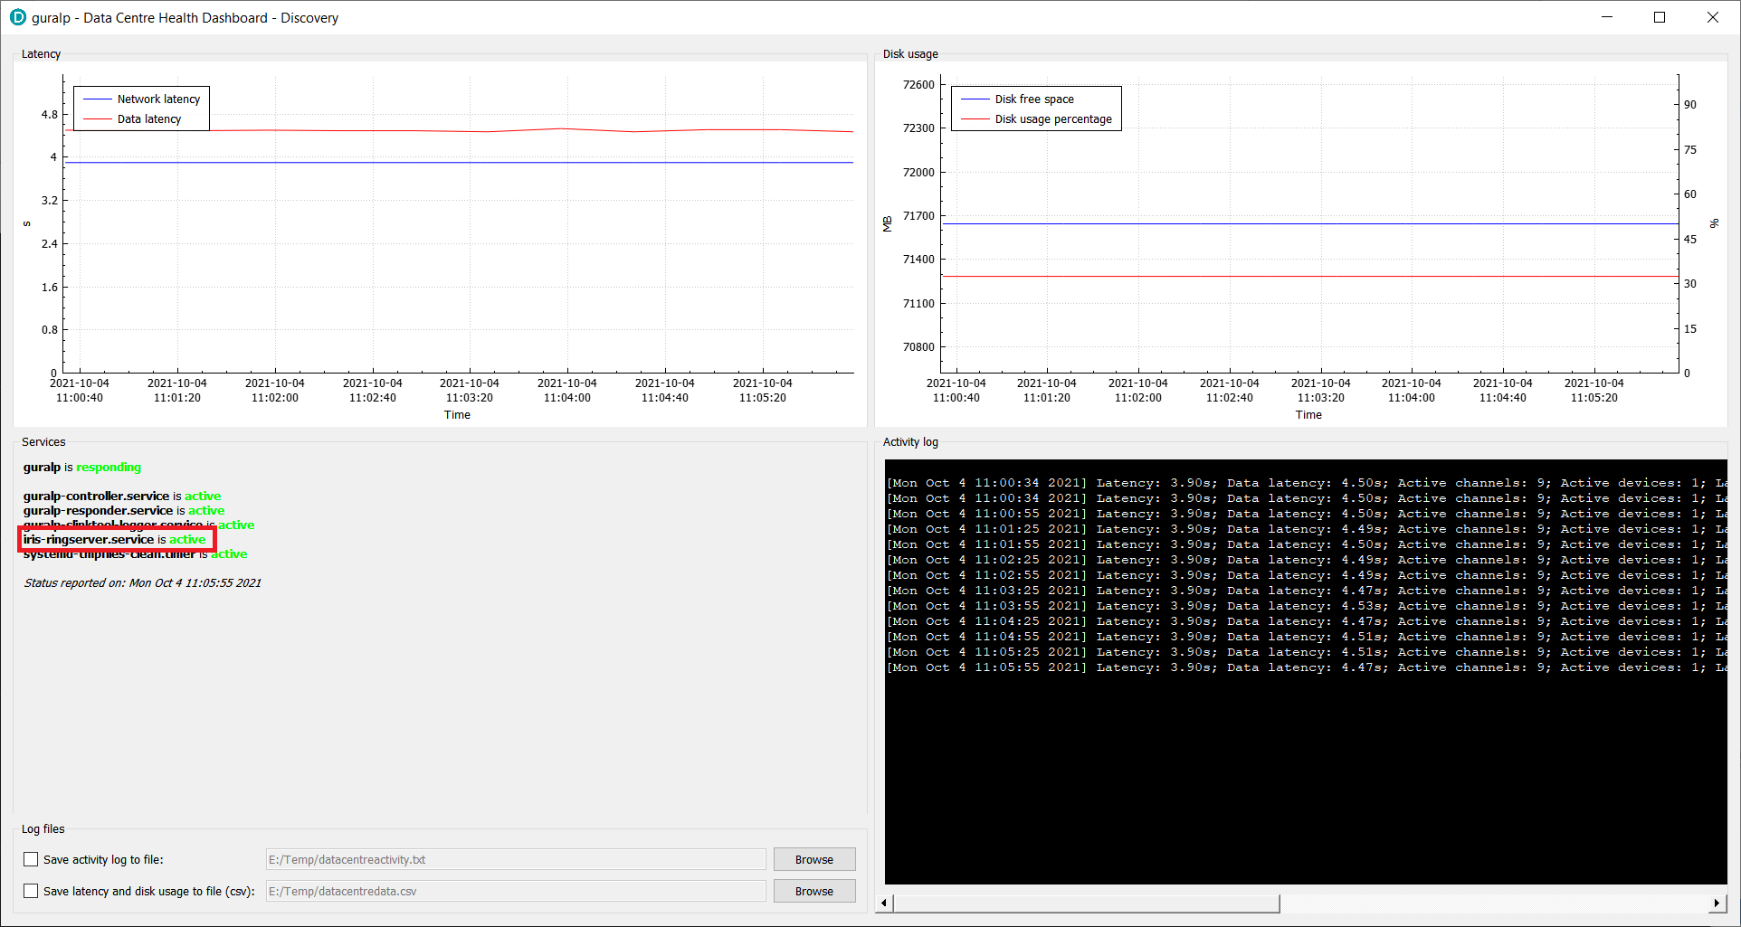

slinktool
Slinktool service is controlled by the Data Centre controller service and does not require operational maintenance. In a rare case when the reported latency seems not to be correct, it is recommended to login to the Data Centre computer and check the relevant slinktool service status using systemctl command.

slink2dali
Slink2dali service is controlled by the Data Centre controller service and does not require operational maintenance. In a rare case when the data is not received on the client side, it is recommended to login to the Data Centre computer and check the relevant slink2dali service status using systemctl command.
Slinktool and slink2dali services can be remotely restarted by removing and re-adding the seismic station to the list of connections in the Data Centre configuration widget.

Güralp Data Centre controller service
Güralp Data Centre controller service does not require regular maintenance. If the service is not responding or configuration exchange between the Discovery desktop application and the Data Centre is not working, please ssh log in to the Data Centre computer and check the status of guralp-controller service:
systemctl status guralp-controller.service
If status returned is different from active:
guralp-controller.service - Güralp data centre controller
Loaded: loaded (/usr/lib/systemd/system/guralp-controller.service; enabled; vendor preset: disabled)
Active: active (running) since Tue 2021-07-20 09:58:27 BST; 6min ago
Main PID: 1660 (guralp-controll)
Tasks: 1 (limit: 48584)
Memory: 12.2M
CGroup: /system.slice/guralp-controller.service
1660 /usr/libexec/guralp-controller -exec
Jul 20 09:58:27 guralp systemd[1]: Started Güralp data centre controller.
Jul 20 09:58:30 guralp guralp-controller[1660]: Service initialised
Jul 20 09:58:30 guralp guralp-controller[1660]: Listening on port 11788
Restart the service using systemctl command:
systemctl restart guralp-controller.service
If problem persists, please contact Güralp Systems support team at support@guralp.com.

Güralp Data Centre monitor service
Güralp Data Centre monitor service sends periodic state of health information packet to all configured Responder servers and performs latency monitoring. If the Data Centre row in the Discovery desktop application is listed as non-responding it means that the application did not receive state of health information from the Data Centre for more than 90 seconds what may indicate that either the server is down, or the Data Centre monitor is not working, or Güralp responder service stopped working, or there is no connection between the Discovery application and the server. In such situation, please try to ssh log in to the server, and if successful check the status of the Data Centre service by running systemctl command:
systemctl status guralp-monitor.service
The service should be in active state:
guralp-monitor.service - Güralp data centre monitor
Loaded: loaded (/usr/lib/systemd/system/guralp-monitor.service; enabled; vendor preset: disabled)
Active: active (running) since Tue 2021-07-20 09:58:27 BST; 20min ago
Main PID: 1659 (guralp-monitor)
Tasks: 4 (limit: 48584)
Memory: 21.2M
CGroup: /system.slice/guralp-monitor.service
1659 /usr/libexec/guralp-monitor -exec
Jul 20 09:58:27 guralp systemd[1]: Started Güralp data centre monitor.
If the service is not in an active state, please try to restart the service using systemctl command:
systemctl restart guralp-monitor.service
If problem persists, please contact Güralp Systems support team at support@guralp.com.
Güralp Data Centre monitor service periodically monitors the slinktool log files in order to gather accurate latency information and feed it to the Güralp responder service for further processing. The highest latency number detected in the configured latency monitoring window is set as Data Centre latency figure and is displayed in the Discovery desktop application. The service records all of the latency data information in a csv and log files stored under home directory of the “slinklat” operating system user, set by default to /var/cache/guralp/latency. Default configuration keeps the recorded data files for 10 days and older files are getting deleted through tmpfiles.d mechanism.

Güralp responder service
Güralp responder service is responsible for collecting and distributing state of health information from Güralp devices. Potential problems caused by malfunction in the service operation will cause the Discovery desktop application to display incorrect state of health information or the list of devices in the application main windows will be empty under the “Registry” mode. If the responder service is malfunctioning, please ssh log in to the Data Centre computer and verify the state of the service by executing the following systemctl command:
systemctl status guralp-responder.service
Service should be in active state:
guralp-responder.service - Güralp responder (a.k.a. Güralp registry server)
Loaded: loaded (/usr/lib/systemd/system/guralp-responder.service; enabled; vendor preset: disabled)
Active: active (running) since Tue 2021-07-20 11:06:17 BST; 7min ago
Main PID: 1639 (guralp-responde)
Tasks: 5 (limit: 48584)
Memory: 500.0K
CGroup: /system.slice/guralp-responder.service
1639 /usr/libexec/guralp-responder -d
Jul 20 11:06:17 guralp guralp-responder[1639]: Discovery Server version 0.80-0091
Jul 20 11:06:17 guralp guralp-responder[1639]: Devices expire after one day
Jul 20 11:06:17 guralp guralp-responder[1639]: Opening pinger UDP listener, port 11788
Jul 20 11:06:17 guralp guralp-responder[1639]: Socket 4
If the service is not in an active state, please try to restart the service using systemctl command:
systemctl restart guralp-responder.service
If problem persists, please contact Güralp Systems support team at support@guralp.com.

Güralp Discovery application
Güralp Discovery is a standalone application dedicated to run in a desktop environment with Windows, Linux or Mac operating system. The application provides multiple functionalities for controlling, diagnosing and monitoring Güralp Systems devices and software products. For the Data Centre acquisition software solution, Discovery is used for configuration and monitoring the Data Centre server state of health.

State of Health
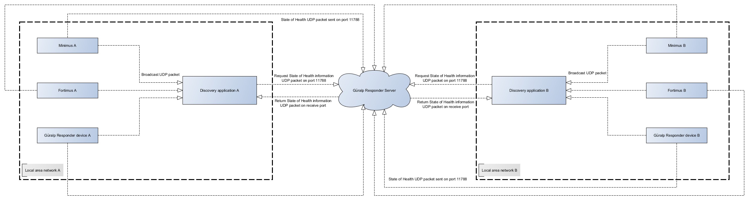
The graph above shows the state of health packet circulation in an environment with 2 local area networks and 1 Güralp responder server instance. The Data Centre software package includes Güralp responder service and the Data Centre acts as a server.
State of health information can be delivered to the Discovery application in 2 ways:
- In a local network, state of health information can be broadcasted by UDP packet sent on port 11788, Discovery is listening to the valid broadcast packets and lists the device in the applications main window table under “local” mode.
- State of health information can be sent directly to Güralp responder server where it is collected and distributed to the Discovery upon request. In “Registry” mode the application is querying the responder periodically for the latest information.
The Data Centre state of health can be monitored in the real time either in the Discovery desktop application main window by checking the status indication icons, and/or by accessing the dedicated Data Centre state of health widget.
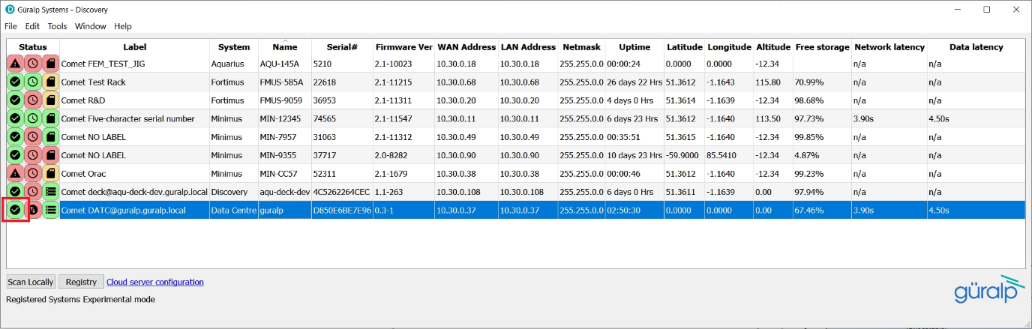
First status icon indicates the active state of the Data Centre. Active state traffic light colour scheme indicates the following:
- Green background – state of health information was received in last 30 seconds.
- Amber background – system is booting.
- Red background – state of health information was not received for more than 90 seconds.
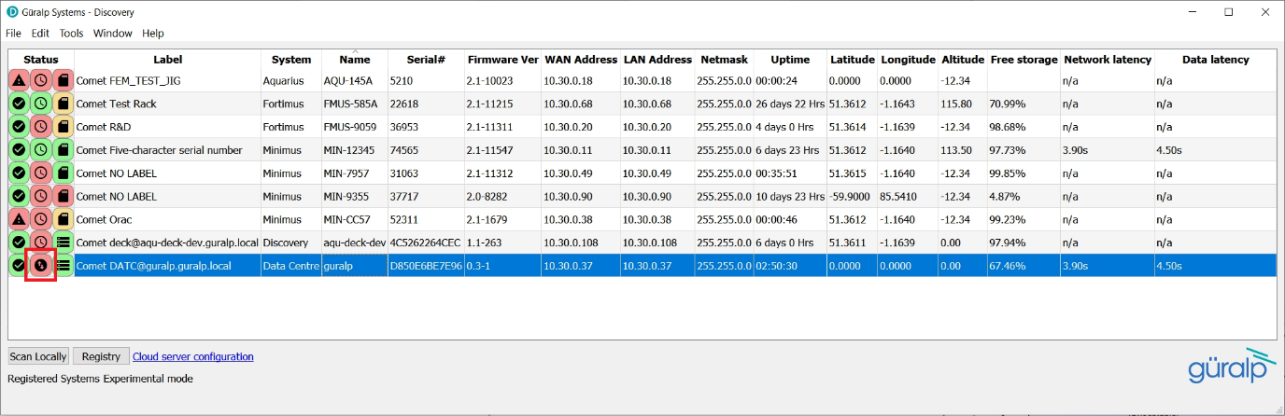
Second status icon indicates the latency status of the data coming in to the Data Centre. Data Centre monitors the latency of all channels received and satisfied by the latency channels monitoring filter and sends the highest latency in the state of health information packet. The latency status traffic light colour scheme indicates the following:
- Green background – the highest latency value is below 1 second.
- Amber background – the highest latency value is between 1 second and 1.5 second.
- Red background – the highest latency value is above 1.5 second.
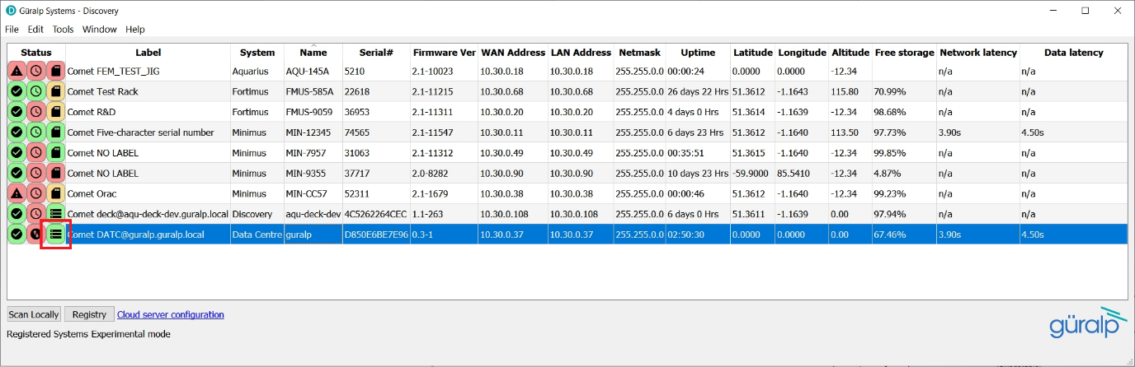
The last, third status icon shows the Data Centre storage status. The traffic light colour scheme for the Data Centre storage indicates the following:
- Green background - more than 50% of disk space is free.
- Amber background – between 20% and 50% of disk space is free.
- Red background – less than 20% of disk space is free.
More descriptive tooltip is provided when hovering over the status icons of a given device:
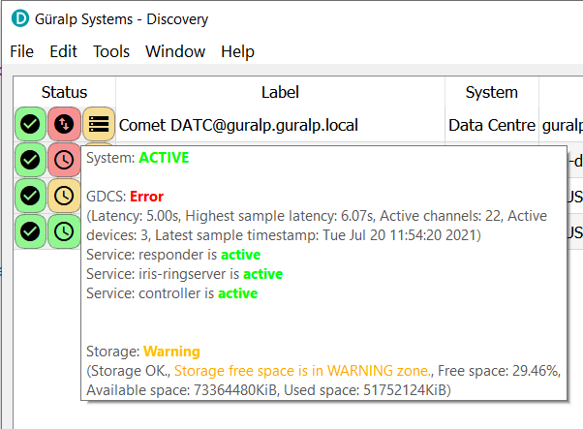
Data Centre state of health dashboard widget can be accessed through right-click menu of selected instance:
The state of health dashboard widget is divided into 4 main parts:
- Top-left widget is a latency graph displaying the highest historical latency value for up to last 30 minutes. 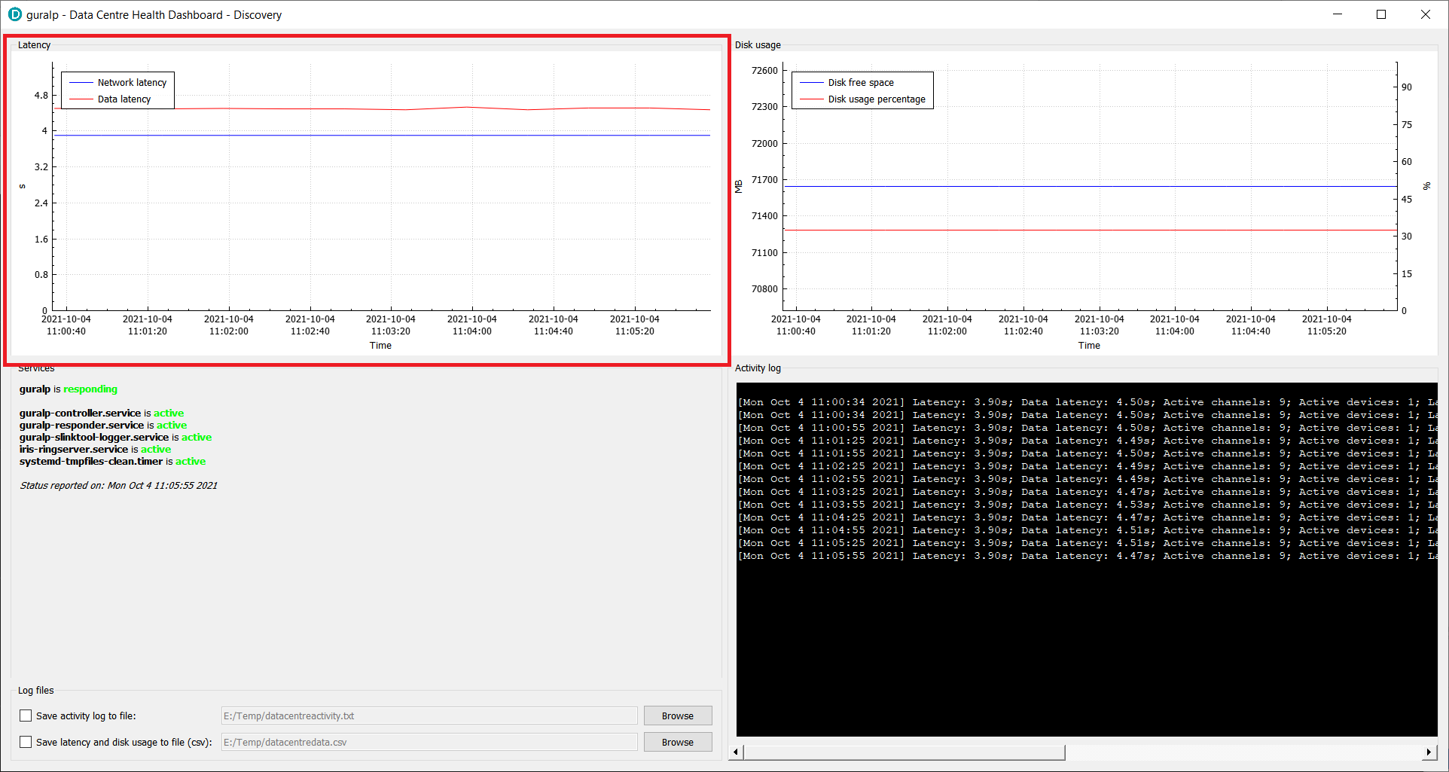
- Top-right widget is a disk usage graph displaying the disk free space in MB (blue graph, left y axis) and disk used space percentage (red graph, right y axis)
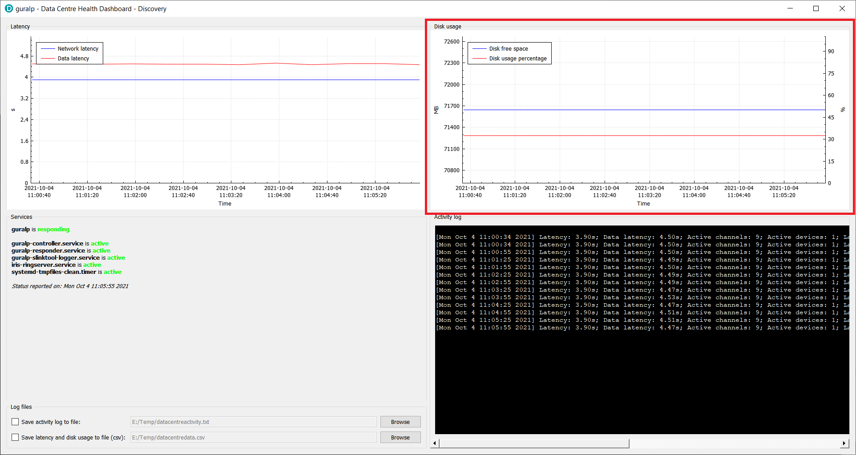
- Bottom-left widget displays the state of services running on the Data Centre and allows to configure the logfile and output data file for activity log and latency/disk usage data respectively
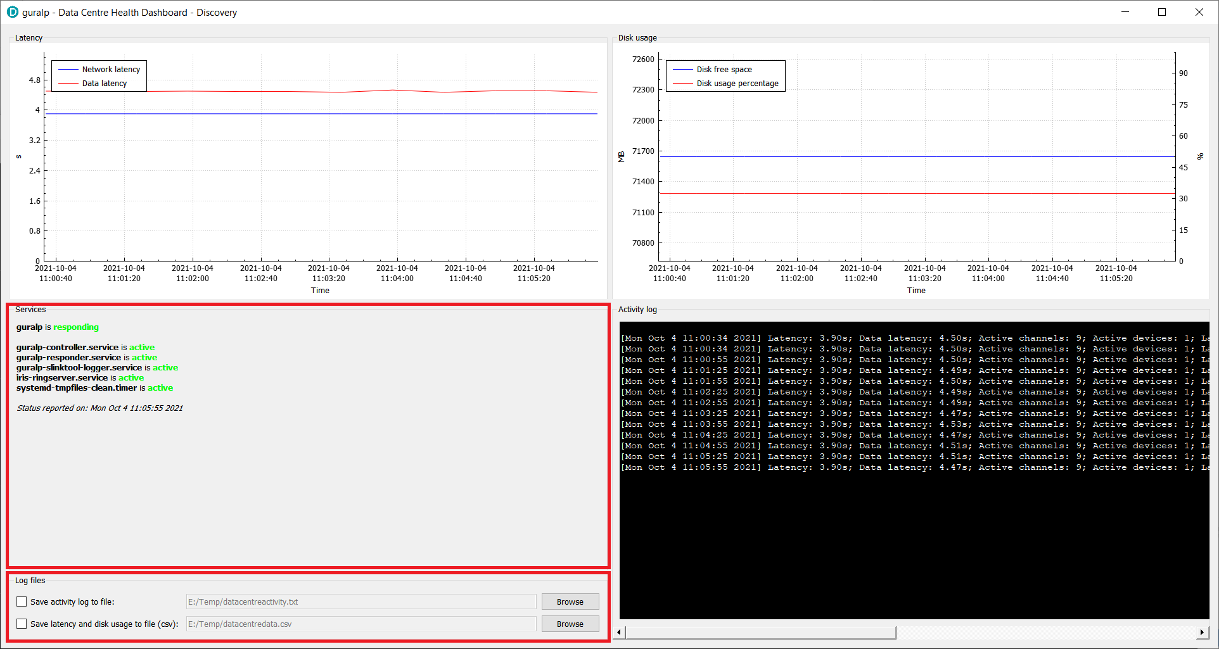
- Bottom-right widget displays the activity log based on state of health information packets received
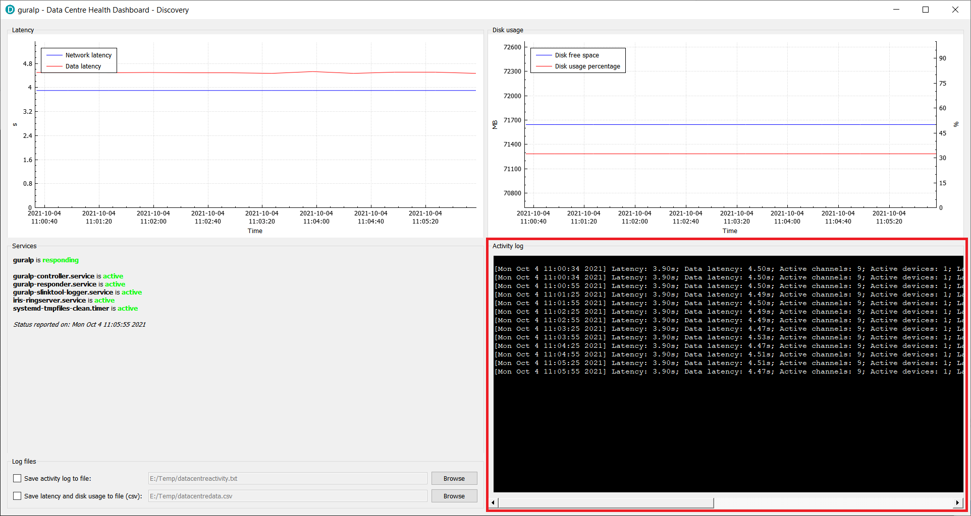
Log line contains the following information:
  - Timestamp
  - Latency value
  - Sample latency value
  - Number of active channels
  - Number of active devices
  - Latest sample timestamp
  - Available disk space in KB
  - Disk used space in KB
  - Percentage value of free disk space
And is logged as single line in the following format:
{[Timestamp]} Latency: {Latency value}s; Sample latency: {Sample latency value}s; Active channels: {Number of active channels}; Active devices: {Number of active devices}; Latest sample timestamp: {Latest sample timestamp}; Disk available: {Available disk space in KB}; Disk used: {Disk used space in KB}; Disk free: {Percentage value of free disk space}%;
Example:
[Fri Jul 9 13:50:34 2021] Latency: 1.50s; Sample latency: 1.81s; Active channels: 26; Active devices: 2; Latest sample timestamp: Fri Jul 9 13:49:43 2021; Disk available: 73364480; Disk used: 54698232; Disk free: 25.44%;

Configuration
Under normal operation tweaks to the health monitor configuration, list of connected devices or Güralp responder server connections might be required. For connecting or disconnecting from the stations please refer to Configuration/Slink2dali section of this document, and for modification of the Discovery desktop application responder server connection please refer to Configuration/Güralp Discovery application section.
Güralp Discovery application provides a configuration widget for the Data Centre accessible through right-click menu in the application main window.
The configuration widget is split in 3 parts:
- General settings, providing a set of text edit fields for Güralp Data Centre monitor:
  - Registry group identifier – Group identifier used for registration to the Güralp responder server.
  - Monitoring period for latency channels – Period of time in seconds that should be used for detecting the highest channel latency value.
  - Monitoring period for active channels – Period of time in seconds that should be used for detecting the number of active channels.
  - Monitoring period for active devices – Period of time in seconds that should be used for detecting the number of active devices.
  - Filter for active channels monitoring – A SEED globing pattern defining the channels that are monitored for being active. Accepts a space (‘ ‘) separated list.
  - Filter for channels latency monitoring – A SEED globing pattern defining the channels that are monitored for latency calculation. Accepts a space (‘ ‘) separated list.
  - Storage information base location – Location that should be used for disk space information gathering. Leave blank for default (the service working directory).
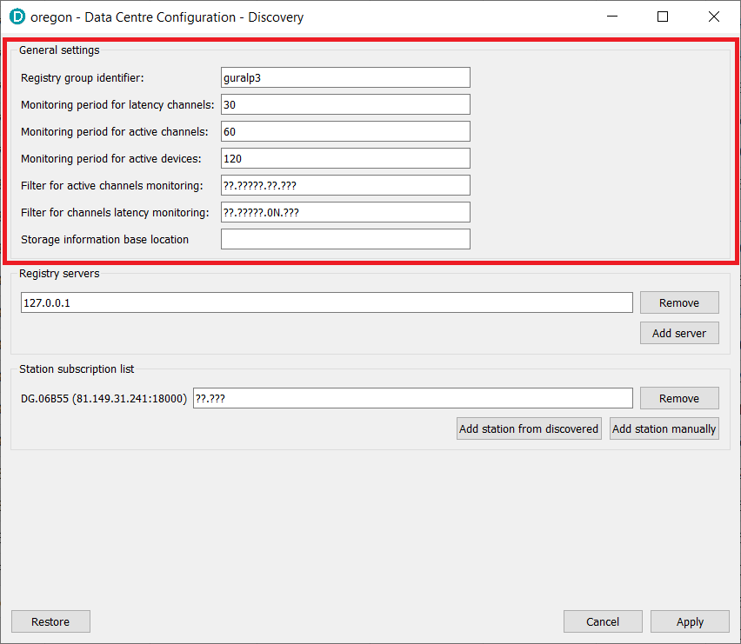
- Registry servers, containing a list of Güralp responder server addresses that the Data Centre should notify its state of health to. At least one entry connecting to local loopback address (local instance of the responder service) should be configured. Additional servers can be added for redundancy and access extension by clicking on “Add server” button and providing the connection details.
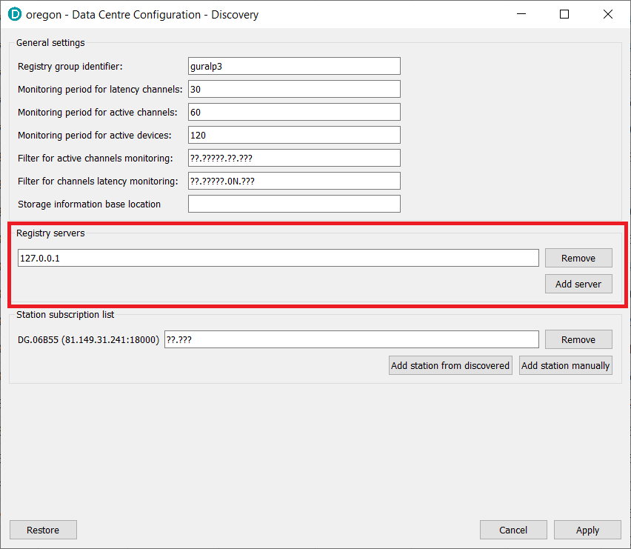
- Station subscription list, defining a list of all of the stations and channels that the Data Centre should connect to as described in Configuration/slink2dali section.
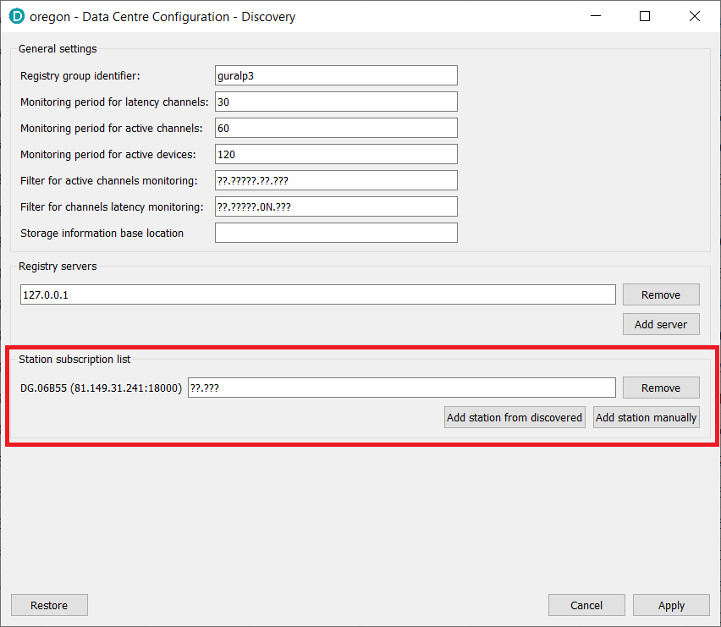

Support
For support enquiries, please contact support@guralp.com.
Güralp Systems Limited
Midas House, Calleva Park, Aldermaston,
Reading, RG7 8EA,
United Kingdom
Tel: +44 118 981 9056
Fax: +44 118 981 9943
E-mail: sales@guralp.com

Version
Version | Date | Author | Comment
1 | 2021/08/03 | P Grabalski | Initial upload
2 | 2021/08/04 | P Grabalski | Spelling corrections
3 | 2021/08/24 | P Grabalski | Update of “Configuration/Güralp responder service” section to show latest configuration file content (pipe file configuration line added)
4 | 2021/10/04 | P Grabalski | Screenshots update to reflect widgets from Discovery version 1.1-267
5 | 2021/11/01 | P Grabalski | Screenshots update to contain default data centre group ID “guralp3”.  Security sub-section added to operating system section to explain the networking requirements.

